Sales Trend and Inventory Optimization Analysis
of Anand Pharma, Darbhanga
A Mid-Term Project Report | Primary Data Pathway (Jan–June 2026)

Submitted by:
Name: Shudhanshu Kumar Yadav | Roll Number: 23F1000204
Email: 23f1000204@ds.study.iitm.ac.in
IITM Online BS Degree Program
Indian Institute of Technology Madras, Chennai
August 2026

Content / Index Page
Table of contents indicating major report sections, sub-sections, and page numbers:
Section No. | Section Heading | Page No.
1. | Executive Summary and Title | 3
2. | Proof of Data Originality | 4
2.5 | Problem Statement and Business Objectives | 4
3. | Metadata and Descriptive Statistics | 5
3.1 | Metadata Definition and Dataset Structure | 5
3.2 | Descriptive Statistics and Quantitative Summary | 5
4. | Detailed Explanation of Analysis Process / Method | 6
4.1 | Data Cleaning and Preprocessing | 6
4.2 | Analytical Methodologies and Mathematical Abstractions | 6
5. | Results and Findings (Preliminary Insights) | 7
5.1 | ABC Classification & Pareto Analysis Findings | 7
5.2 | FSN Inventory Movement & Expiry Risk Findings | 8
5.3 | Monthly Sales Trends & Seasonal Demand Fluctuations | 9
5.4 | Moving Average Demand Forecast Results | 10
6. | Interpretation of Results and Recommendations | 11

1. Executive Summary and Title
Project Title: Sales Trend and Inventory Optimization Analysis of Anand Pharma, Darbhanga
Anand Pharma is a retail B2C pharmacy store established in 2018 and operated by Mr. Krishan Mohan Yadav in Donar, Darbhanga, Bihar (GSTIN: 10AEY3656A1Z4), procuring primarily from M/s. Sonu Pharma, Patna. The store encounters inventory challenges including seasonal demand fluctuations and intuition-based restocking decisions, resulting in stockouts of high-demand items, overstocking, and capital loss from expired medicines.
Primary sales, purchase, and stock data spanning 6 consecutive months (January to June 2026) were collected directly from physical vouchers and sales registers via remote digital transmission. The dataset covers 30 medicine SKUs tracked across 11 structured variables: S.No, Medicine Name, Category, MRP (₹), Purchase Price (₹), Opening Stock, Purchase Qty, Sales Qty, Closing Stock, Total Revenue (₹), and Expiry Date. Key descriptive statistics show mean revenue of ₹43,521.83 per SKU (median ₹41,108.50), total store revenue of ₹13,05,655, and an average gross margin of ~29.8%.
Quantitative techniques — ABC Analysis, FSN Classification, Pareto (80/20) Analysis, and 3-Month Moving Average Demand Forecasting — were executed. Preliminary findings reveal that 14 Category A medicines (46.7% items) generate 69.0% of revenue; 18 SKUs drive 80% cumulative revenue (Pareto cutoff); 5 Non-Moving SKUs carry high expiry risk; and May 2026 recorded peak revenue (₹2,43,998 — a 23.8% surge over April). Moving Average forecasts for July 2026 were generated for all SKUs to guide proactive procurement.

2. Proof of Data Originality
Primary data for 6 consecutive months (January 2026 to June 2026) was collected directly from M/s. Anand Pharma, Donar, Darbhanga, Bihar (GSTIN: 10AEY3656A1Z4; Proprietor: Mr. Krishan Mohan Yadav) through a remote digital pathway (scanned purchase tax invoices and daily sales registers shared via WhatsApp, cross-verified via telephonic calls).
● Primary Sales, Purchase & Inventory Dataset (Jan–June 2026): [Click Here]
● Distributor Purchase Invoices & GST Details (M/s. Sonu Pharma): [Click Here]
● Pharmacy Firm Images & Servicescape Photos: [Click Here]
● Interaction Video (4-minute interaction with Proprietor in Hindi): [Click Here]
● Official Authorization Letterhead (Signed & Stamped): [Click Here]
● Academic Location & Remote Data Collection Clarification Note: [Click Here]

2.5 Problem Statement and Business Objectives
Problem Statement 1: Minimizing Stockouts of High-Demand Medicines
Intuition-based purchasing causes stockouts of high-demand items (e.g., Ceroxim CV 500, Abzolid 600), leading to lost revenue. Objective: Apply ABC/Pareto classification to maintain 15-day safety buffer stocks for Category A items.
Problem Statement 2: Preventing Capital Loss from Unsold Expired Stock
Slow-moving SKUs risk expiring unsold, causing direct capital loss. Objective: Execute FSN classification to flag Non-Moving SKUs for credit returns to distributors 60 days before expiration.
Problem Statement 3: Optimizing Seasonal Procurement via Demand Forecasting
Monthly sales fluctuate seasonally (May 2026 revenue surged 23.8% to ₹2,43,998). Objective: Apply 3-Month Moving Average forecasting to adjust procurement 15-20% in advance of peak seasons.

3. Metadata and Descriptive Statistics

3.1 Metadata Definition and Dataset Structure
The dataset covers 6 monthly sheets (JAN2026 to JUN2026) across 30 SKUs. Compact metadata structure:
Sheet Name | Columns | Data Type | Units | Description
1. 'JAN2026'  2. 'FEB2026'  3. 'MAR2026'  4. 'APR2026'  5. 'MAY2026'  6. 'JUN2026' | Medicine Name | string | - | Brand / generic name of the medicine
 | Category | string | - | Therapeutic category (Antibiotic, Gastric Care, etc.)
 | MRP | float | Rupees | Maximum retail selling price per strip/unit
 | Purchase Price | float | Rupees | Wholesale procurement cost per strip/unit
 | Opening Stock | integer | strips | Number of strips in stock at beginning of month
 | Purchase Quantity | integer | strips | Number of strips purchased during the month
 | Sale Quantity | integer | strips | Number of strips sold during the month
 | Closing Stock | integer | strips | Number of strips in stock at end of month
 | Total Revenue | float | Rupees | Gross revenue generated (Sale Quantity x MRP)
 | Expiry Date | string | MM/YYYY | Expiration date printed on medicine packaging
Table 1: Metadata Definition — Compact Monthly Dataset Structure

3.2 Descriptive Statistics and Quantitative Summary
Statistical Metric | MRP (₹) | Purchase Price (₹) | 6M Sales Qty (Strips) | 6M Total Revenue (₹)
Sample Count (N) | 30 | 30 | 30 | 30
Mean (Average) | ₹192.30 | ₹134.87 | 223.40 | ₹43,521.83
Median | ₹179.00 | ₹124.00 | 225.00 | ₹41,108.50
Standard Deviation | ₹110.75 | ₹80.00 | 35.68 | ₹25,890.82
Minimum | ₹45.00 | ₹28.00 | 152 | ₹7,605.00
Maximum | ₹480.00 | ₹340.00 | 317 | ₹1,15,680.00
Range (Max - Min) | ₹435.00 | ₹312.00 | 165 | ₹1,08,075.00
Table 2: Descriptive Statistics — 30 Medicine SKUs (Jan–June 2026)
Key Insights: 1. Mean revenue (₹43,521.83) > Median (₹41,108.50) confirms right-skewed revenue distribution where top SKUs drive majority sales. 2. Sales volume ranges from 152 to 317 strips (SD: 35.68), justifying FSN velocity segmentation. 3. Average gross profit margin per strip is ₹57.43 (~29.8%).

4. Detailed Explanation of Analysis Process / Method

4.1 Data Cleaning and Preprocessing
1. Product Standardization: Variant brand strings across monthly bills (e.g., "Ceroxim CV", "CEROXIM-500") were merged into unified standard SKU identifiers.
2. Wholesale Rate Imputation: Missing purchase rates were backfilled using master distributor tax invoices from M/s. Sonu Pharma, Patna.
3. Mathematical Balance Reconciliation: Every row verified via Closing Stock = Opening Stock + Purchase Qty - Sales Qty.
4. Expiry Date Standardization: Dates formatted to MM/YYYY objects for shelf-life countdown modeling.

4.2 Analytical Methodologies and Mathematical Abstractions
Method 1: ABC Analysis — Periodic Consumption Value PCV = Sales Qty x Purchase Price. Ranked by cumulative revenue: Category A (top 70%), Category B (next 20%), Category C (bottom 10%). Linkage: Identifies priority buffer SKUs (PS1).
Method 2: FSN Analysis — 6-month sales velocity: Fast (Sales >= 250), Slow (190 <= Sales < 250), Non-Moving (Sales < 190). Linkage: Flags high-risk expiring inventory for returns (PS2).
Method 3: Pareto Analysis (80/20 Rule) — Identifies minimal SKU subset driving 80% revenue. Linkage: Focuses purchasing capital on vital few SKUs.
Method 4: 3-Month Moving Average Demand Forecast — F_(t+1) = (S_t + S_(t-1) + S_(t-2)) / 3. Linkage: Predicts seasonal demand shifts for advance ordering (PS3).

5. Results and Findings (Preliminary Insights)

5.1 ABC Classification & Pareto Analysis Findings
Total 6-month store revenue reached ₹13,05,655.00 across 30 SKUs. ABC breakdown: Category A (14 SKUs, 46.7% items) = ₹9,00,660.00 (69.0% revenue); Category B (8 SKUs) = ₹2,72,427.00 (20.9%); Category C (8 SKUs) = ₹1,32,568.00 (10.2%). Top 3 SKUs: Ceroxim CV 500 (₹1,15,680), Abzolid 600 (₹92,568), Chyawanprash 2KG (₹98,100).
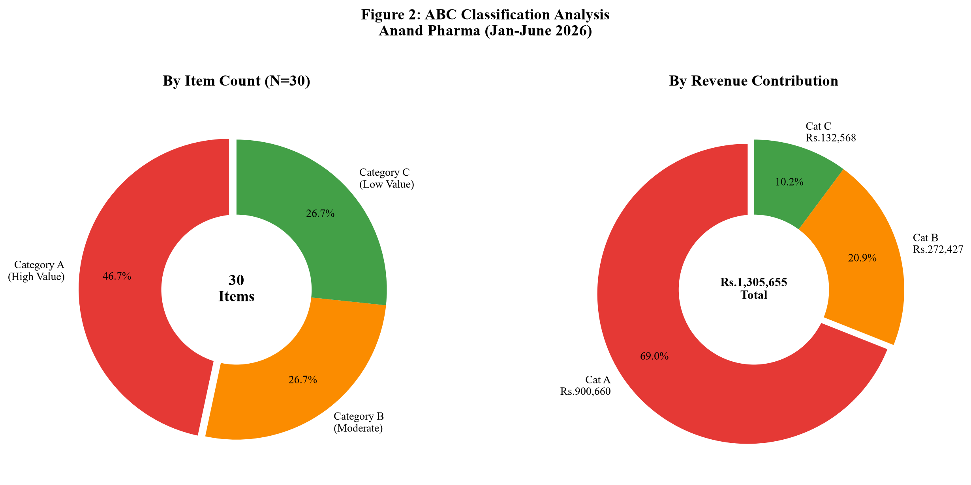
Figure 1: ABC Revenue & Item Distribution
Pareto 80/20 Cutoff: Exactly 18 out of 30 SKUs (60% items) generate 80% of cumulative store revenue, providing a clear cutoff for inventory capital allocation.
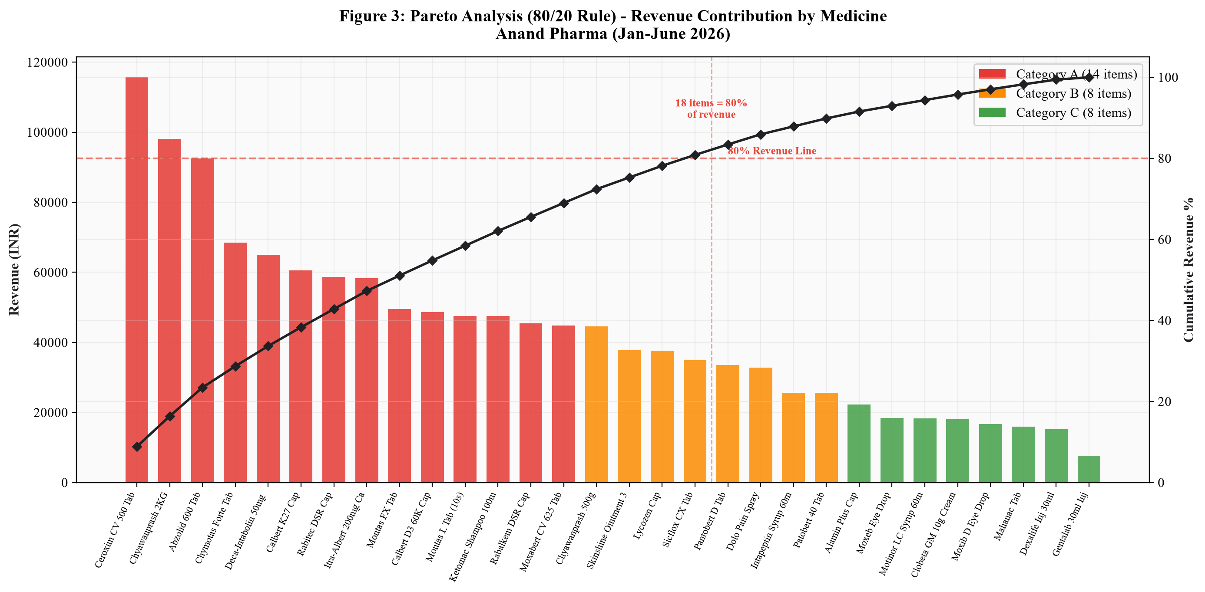
Figure 2: Pareto 80/20 Revenue Contribution

5.2 FSN Inventory Movement & Expiry Risk Findings
FSN Breakdown: Fast Moving F (5 SKUs, 16.7%), Slow Moving S (20 SKUs, 66.7%), Non-Moving N (5 SKUs, 16.7%). 5 Non-Moving SKUs carrying high expiry risk: Gentalab 30ml Inj (169 units), Dexalife Inj 30ml (208 units), Moxib D Eye Drop (152 units), Alamin Plus Cap (170 units), Dolo Pain Spray (168 units).
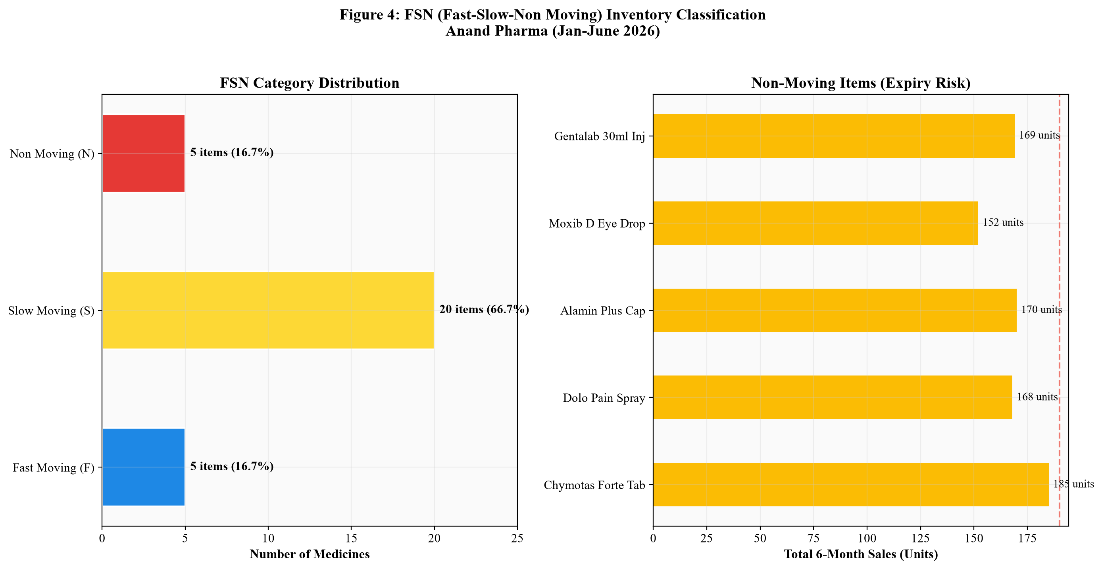
Figure 3: FSN Movement & Expiry Risk Items
ABC-FSN Matrix: Category A - Slow Moving items (10 SKUs) form the largest segment, requiring strict reorder point management to prevent stockouts.
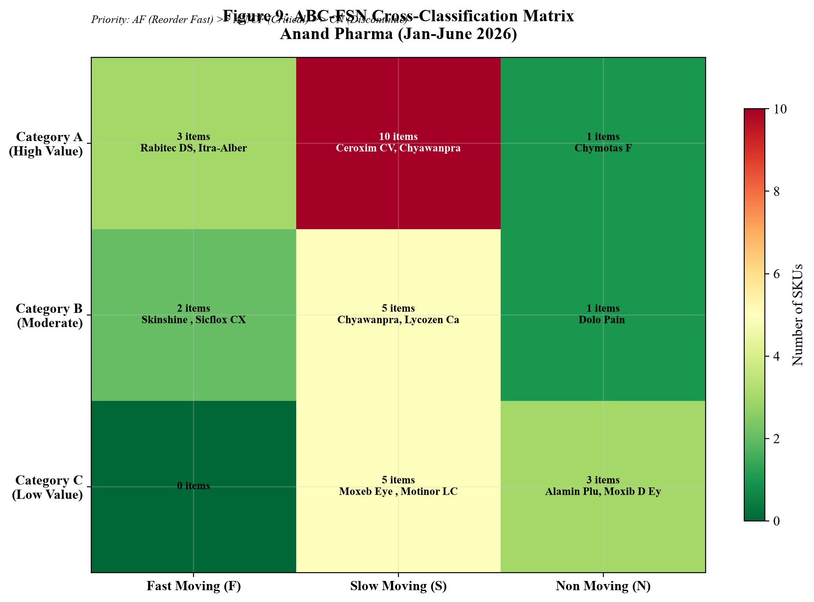
Figure 4: ABC-FSN Priority Matrix

5.3 Monthly Sales Trends & Seasonal Demand Fluctuations
Monthly Store Revenue: Jan (₹2,20,925), Feb (₹2,14,824), Mar (₹2,07,518), Apr (₹1,97,038 - lowest), May (₹2,43,998 - 23.8% pre-monsoon surge), Jun (₹2,21,352). Antibiotics (₹2,87,988) and Gastric Care (₹1,63,259) drive >34% of revenue.
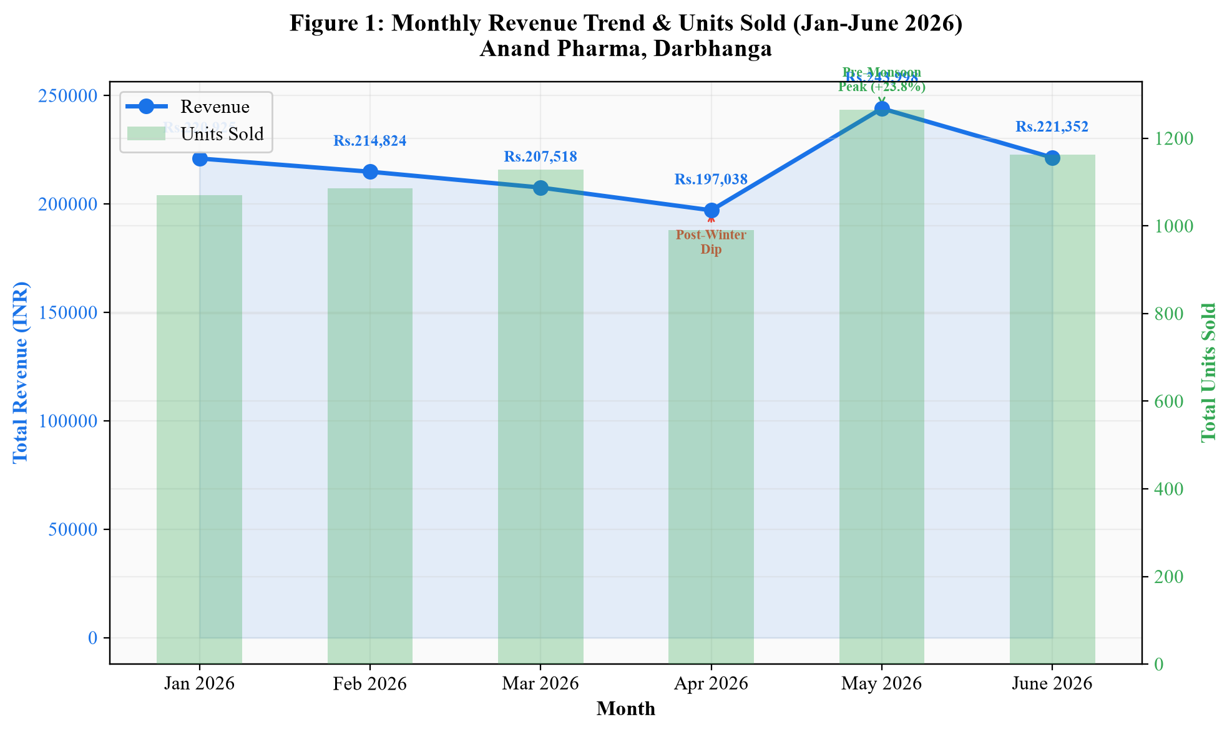
Figure 5: Monthly Revenue & Sales Volume Trend
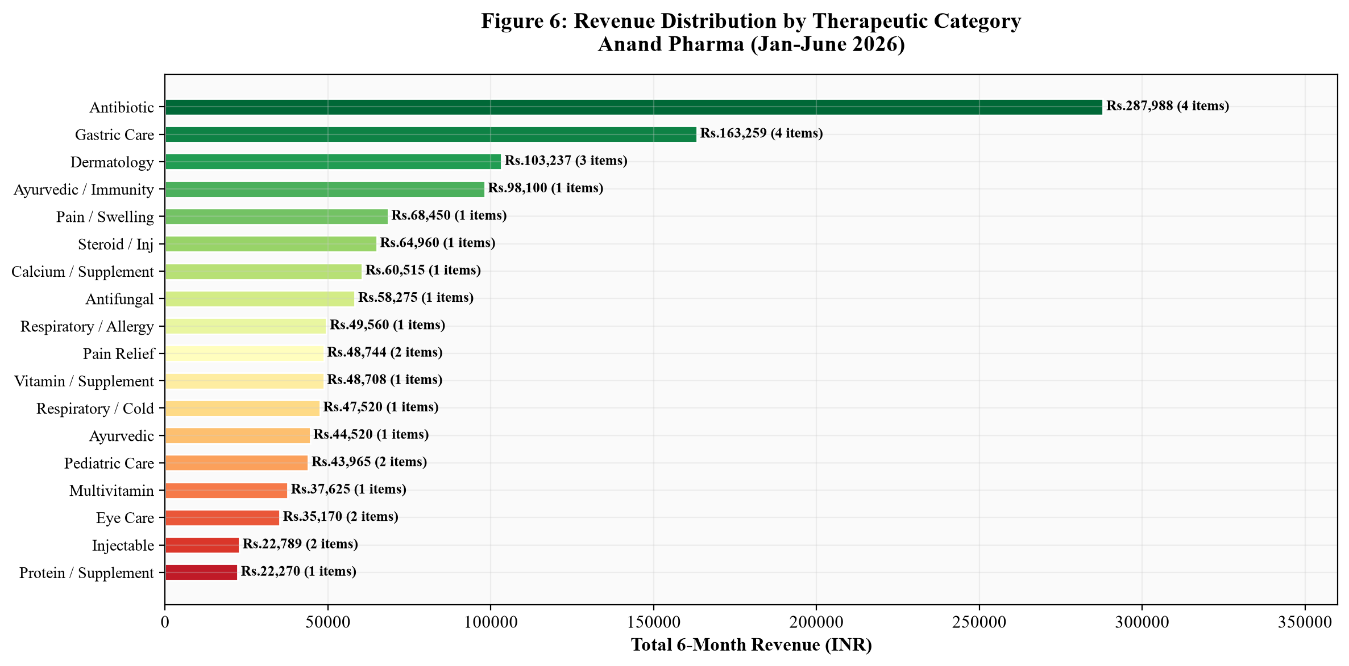
Figure 6: Revenue by Therapeutic Category

5.4 Moving Average Demand Forecast Results
July 2026 Demand Forecasts (3-Month SMA): Ceroxim CV 500 (45 strips), Abzolid 600 (37 strips), Chyawanprash 2KG (32 units - seasonal drop), Chymotas Forte (26 strips). SMA provides a conservative, lag-adjusted baseline for advance ordering.
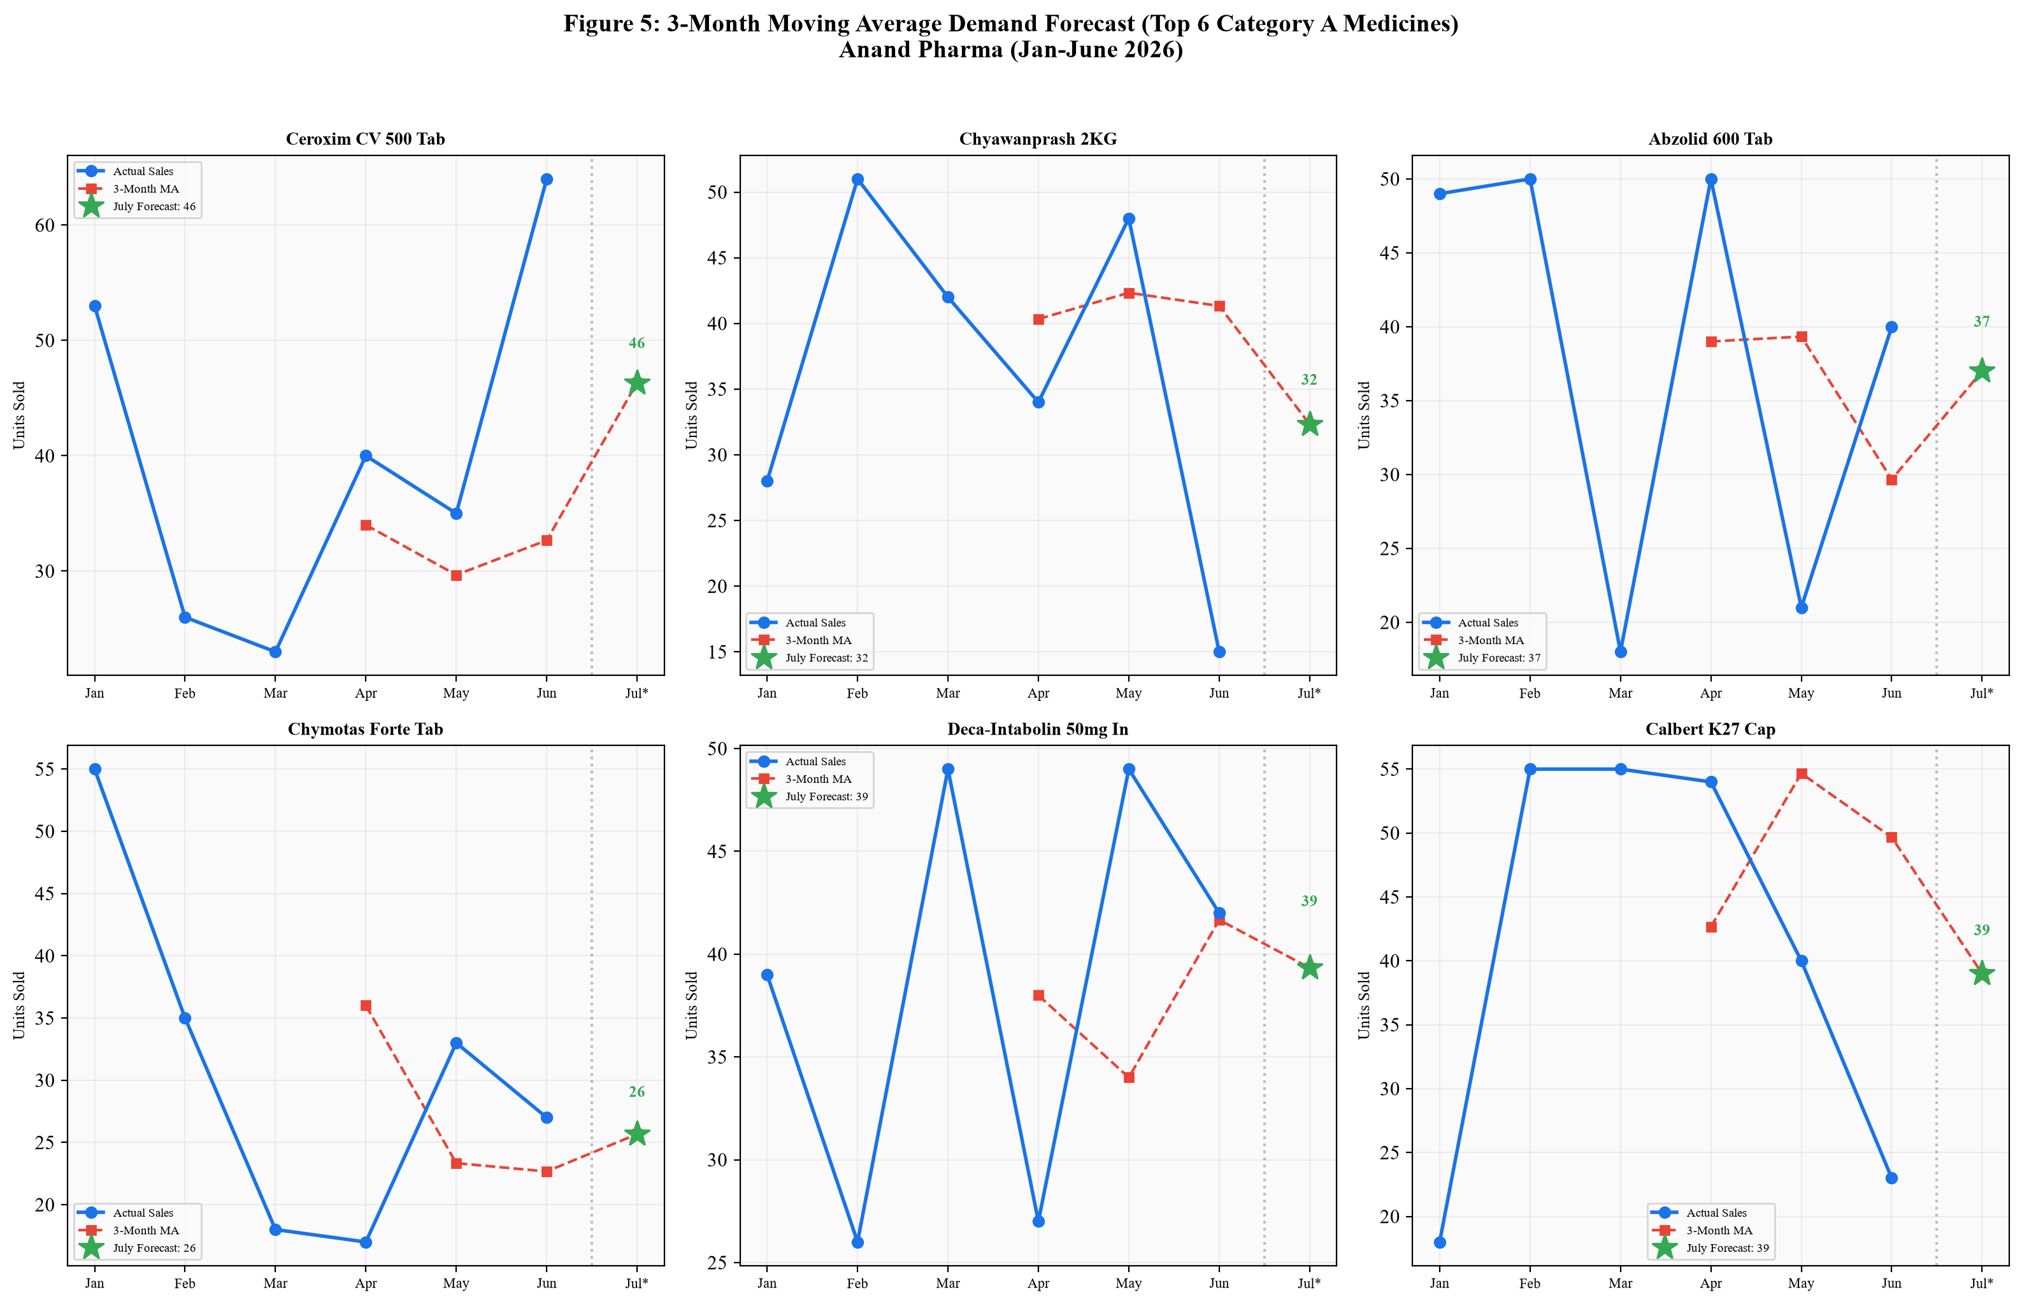
Figure 7: 3-Month Moving Average Demand Forecast (Top SKUs)
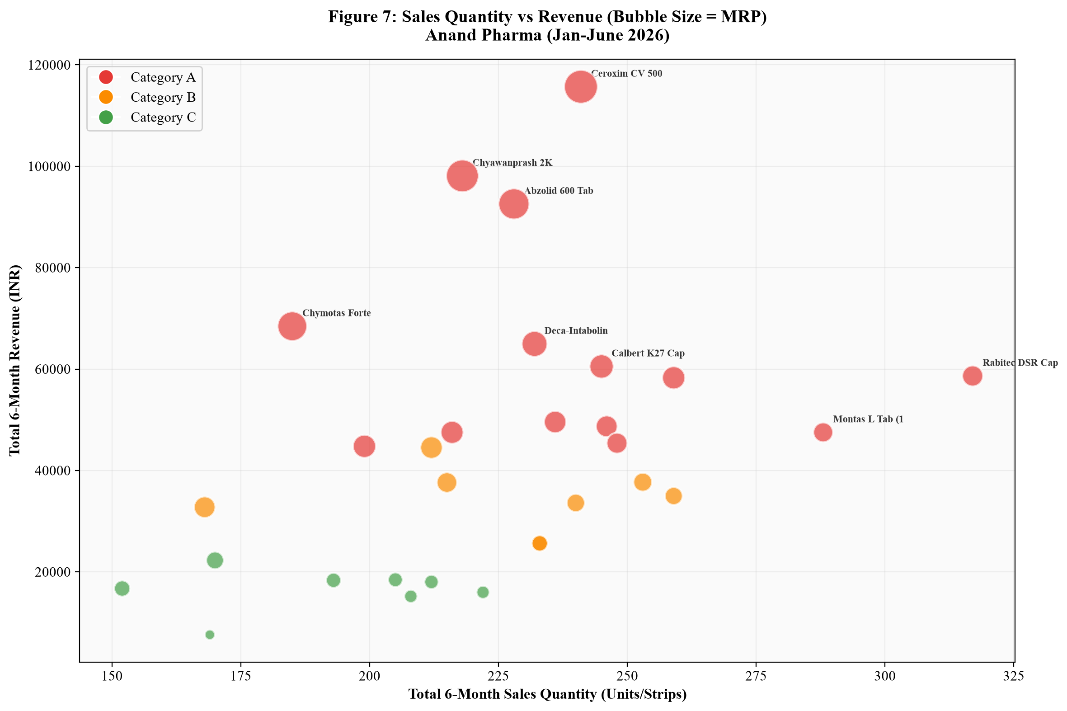
Figure 8: Quantity vs Revenue Bubble Chart (Size = MRP)

6. Interpretation of Results and Recommendations
1. Category A Safety Buffer Stocking (Addresses PS1): Maintain a 15-day safety buffer for Category A SKUs (Ceroxim CV, Abzolid) using Reorder Point = Avg Daily Sales x Lead Time + Buffer.
2. Pre-Expiry Credit Returns (Addresses PS2): Implement a 60-day pre-expiry audit to return 5 Non-Moving SKUs (Gentalab Inj, Dexalife Inj) to distributor M/s. Sonu Pharma for credit notes.
3. Seasonal Advance Ordering (Addresses PS3): Increase Antibiotic and Gastric orders by 15-20% in April to capture the May-June pre-monsoon demand surge.
4. Digital Stock Audit Transition: Transition from manual registers to weekly Excel digital tracking for automated low-stock alerts.
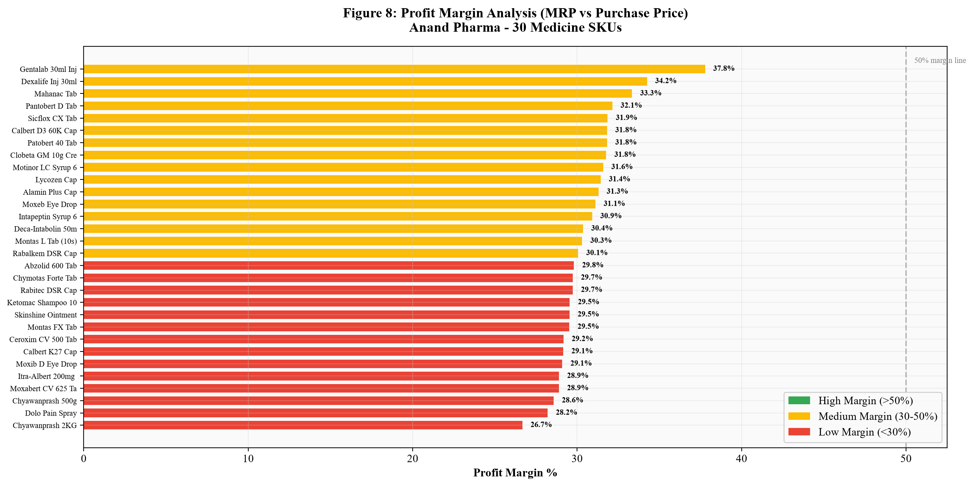
Figure 9: Profit Margin Analysis across 30 SKUs
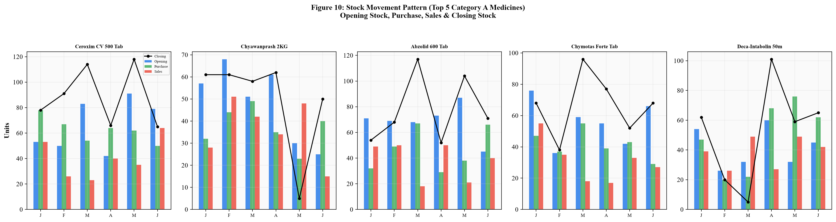
Figure 10: Stock Movement Pattern (Top 5 SKUs)

